**Project B: Flying hornet**

Name: Yipeng Pan

NetID: YPK6670

Instruction:

There is a hornet on the screen which can start or stop flying. A chess, an ice cream, a hot air balloon and a pyramid surround it. The pyramid rotates with the mouse dragging on the screen. Users can also coordinate the camera to any direction or position.

User Guide:

Press K on the keyboard to let the hornet start to fly and press L to stop if flying. Drag your mouse to rotate the pyramid. Use arrow keys to rotate your camera in horizontal and vertical directions and use W, A, S, D to move your camera or zoom in and out.

Pictures:

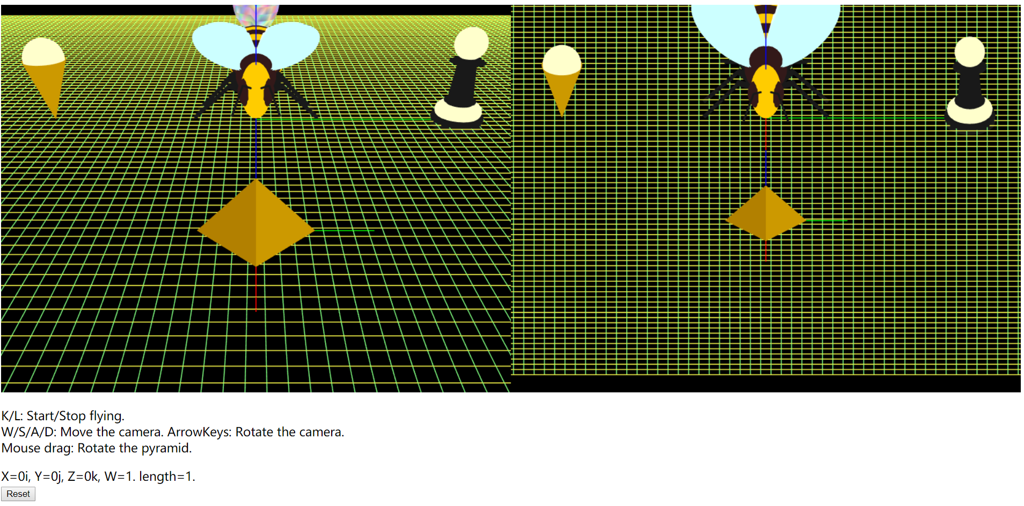

Figure

Figure 1 is the initial scene, perspective view at the left and orthographic view at the right. The hornet at the middle with the pyramid in the front, the hot air balloon in the back, the ice cream at the left and the chess at the right.

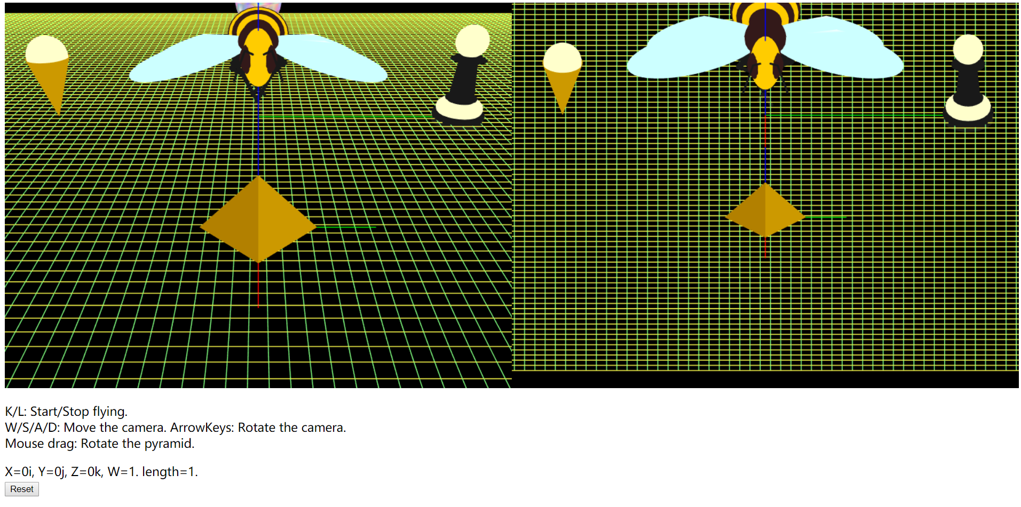

Figure Flying hornet

Press K on the keyboard, then the hornet start to fly.

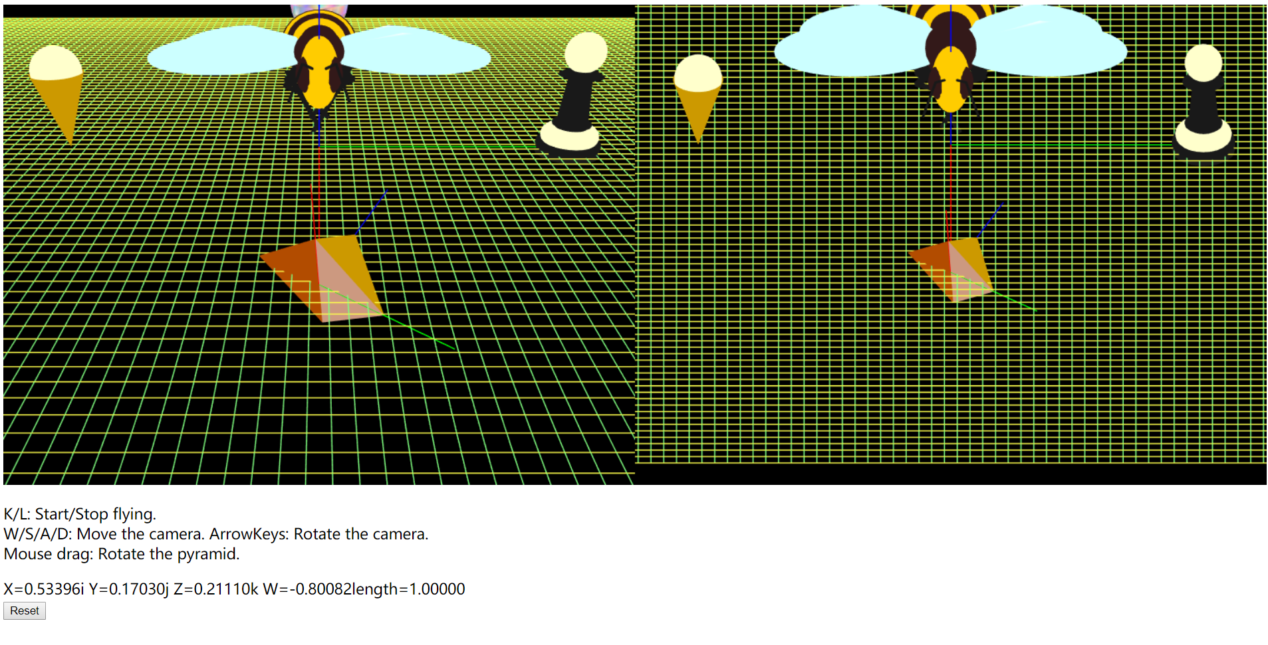

Figure Mouse dragging

Drag your mouse to rotate the pyramid.

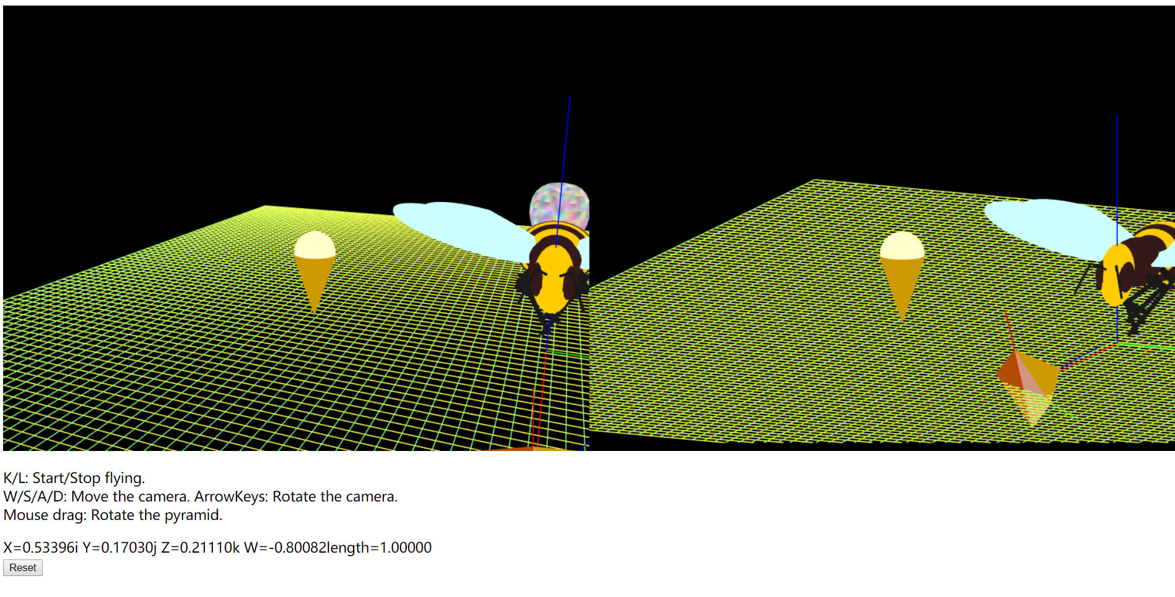

Figure Rotation of the camera

Use arrow keys to rotate your camera, you can get the camera facing toward any direction you want.

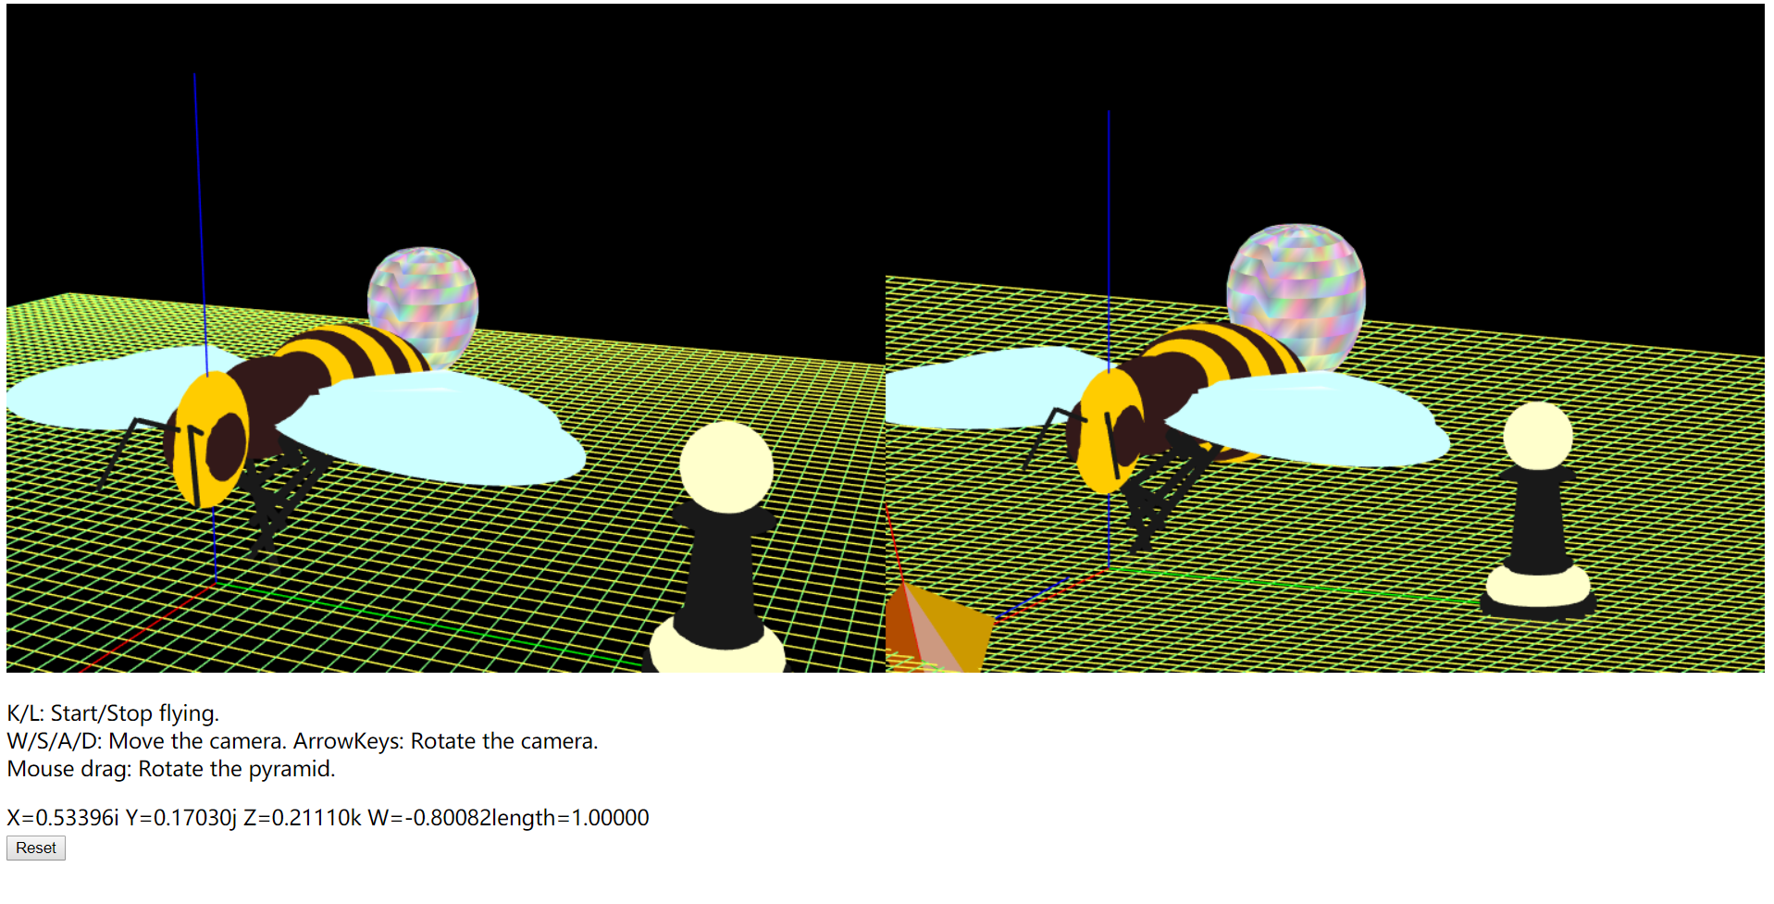

Figure Move the camera and zoom in

You can use W, A, S, D to move the camera perpendicular to the direction of the camera and zoom in or out along the direction of the camera.